Dihedral Angle
# Source: AI Source: Provided by: [Data Path: Persons Table -> ID Column: 1, Name_En Column: Motasem Essam] -> From: [ChatGPT] on [7/25/2026]
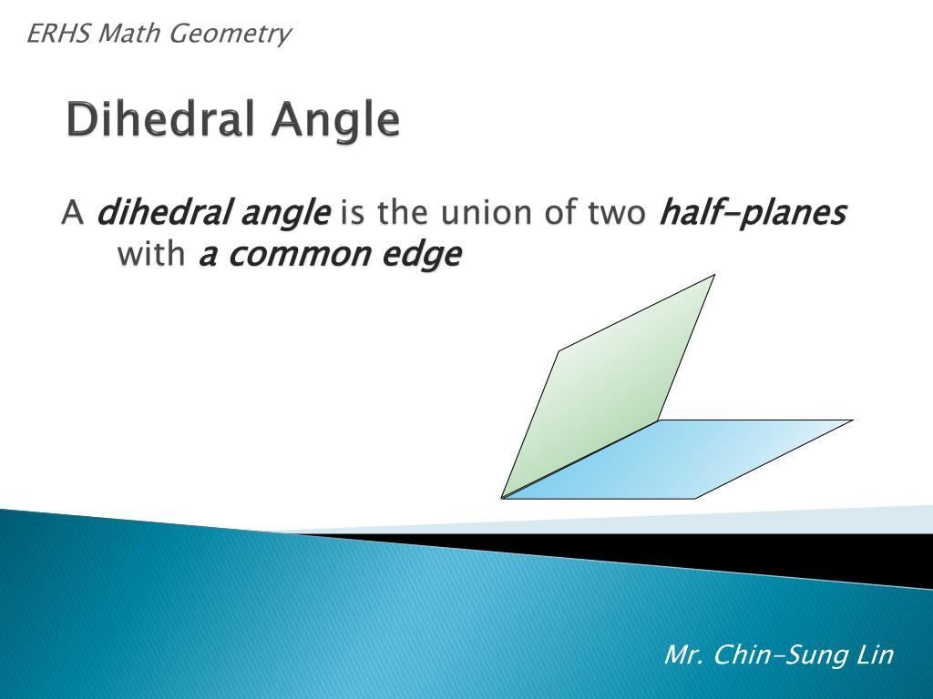
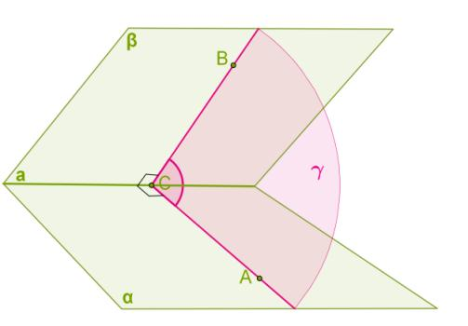
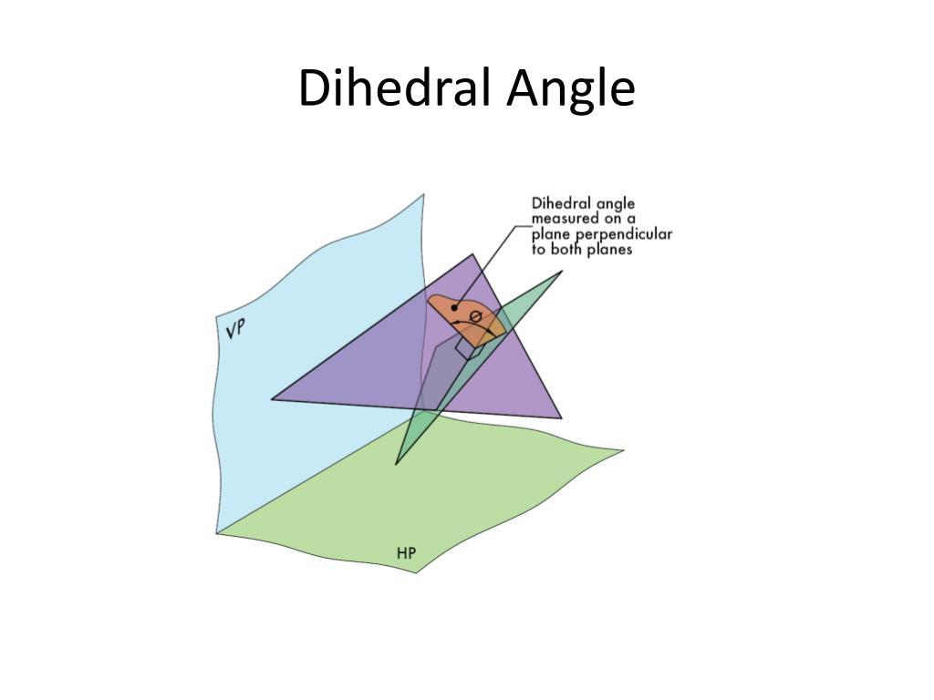

Definition
# Source: AI Source: Provided by: [Data Path: Persons Table -> ID Column: 1, Name_En Column: Motasem Essam] -> From: [ChatGPT] on [7/25/2026]
A dihedral angle is the angle formed between two planes that intersect along a common line, called the edge or line of intersection of the dihedral angle.
Unlike a plane angle, which is formed by two rays in a single plane, a dihedral angle describes the angular relationship between two planes in three-dimensional space.
To measure a dihedral angle, take a cross-section perpendicular to the common edge. The two planes intersect this cross-section along two rays, and the angle between those rays represents the dihedral angle.

Simple Definition
# Source: AI Source: Provided by: [Data Path: Persons Table -> ID Column: 1, Name_En Column: Motasem Essam] -> From: [ChatGPT] on [7/25/2026]
A dihedral angle is the angle between two flat surfaces that meet along an edge.
For example:
- Two adjacent faces of a cube form a dihedral angle of ${90}^{∘}$.
- Two faces of a roof may meet at an acute or obtuse dihedral angle.
- Two pages of an open book form a dihedral angle that changes as the book opens or closes.

Key Characteristics
# Source: AI Source: Provided by: [Data Path: Persons Table -> ID Column: 1, Name_En Column: Motasem Essam] -> From: [ChatGPT] on [7/25/2026]
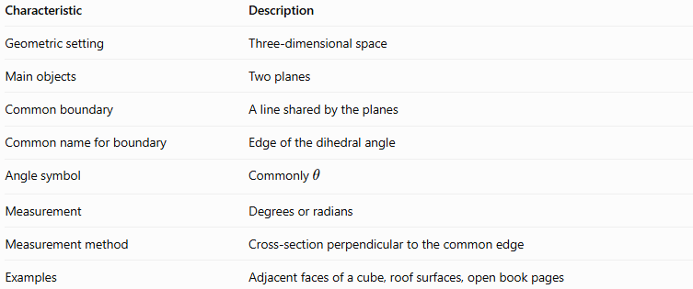
Characteristic | Description
Geometric setting | Three-dimensional space
Main objects | Two planes
Common boundary | A line shared by the planes
Common name for boundary | Edge of the dihedral angle
Angle symbol | Commonly $θ$
Measurement | Degrees or radians
Measurement method | Cross-section perpendicular to the common edge
Examples | Adjacent faces of a cube, roof surfaces, open book pages

Geometric Representation
# Source: AI Source: Provided by: [Data Path: Persons Table -> ID Column: 1, Name_En Column: Motasem Essam] -> From: [ChatGPT] on [7/25/2026]
Suppose two planes, $α$ and $β$, intersect along line $l$.
- Plane $α$ forms one face of the dihedral angle.
- Plane $β$ forms the other face.
- Line $l$ is their common edge.
- The angle $θ$ is measured in a cross-section perpendicular to $l$.
Schematic of two planes sharing a common edge. The angle is measured in a suitable cross-section perpendicular to that edge.
The diagram shows the two plane faces and their common edge. The exact angle is most clearly defined by cutting the planes with a plane perpendicular to that edge.
Perpendicular cross-section
The cross-section turns the dihedral-angle measurement into an ordinary plane angle between two rays.

Mathematical Representation and Formulas

A. Using normal vectors
# Source: AI Source: Provided by: [Data Path: Persons Table -> ID Column: 1, Name_En Column: Motasem Essam] -> From: [ChatGPT] on [7/25/2026]
Let the two planes have normal vectors
$$n_{1}=\left(A_{1},B_{1},C_{1}\right)$$
and
$$n_{2}=\left(A_{2},B_{2},C_{2}\right).$$
The smaller angle $ϕ$ between the two plane orientations can be calculated using
$$\boxed{ϕ=\cos^{-1}\left(\frac{\left|n_{1}⋅n_{2}\right|}{\left\|n_{1}\right\|\left\|n_{2}\right\|}\right)}$$
This formula gives the smaller angle between the planes, between $0^{∘}$ and ${90}^{∘}$.
The dot product is
$$n_{1}⋅n_{2}=A_{1}A_{2}+B_{1}B_{2}+C_{1}C_{2.}$$
The vector magnitudes are
$$\left\|n_{1}\right\|=\sqrt{A_{1}^{2}+B_{1}^{2}+C_{1}^{2}}$$
and
$$\left\|n_{2}\right\|=\sqrt{A_{2}^{2}+B_{2}^{2}+C_{2}^{2}}.$$

B. Interior dihedral angle of a solid
# Source: AI Source: Provided by: [Data Path: Persons Table -> ID Column: 1, Name_En Column: Motasem Essam] -> From: [ChatGPT] on [7/25/2026]
For the interior angle between two faces of a solid, the relevant angle depends on which half-planes are selected. If the interior angle is the supplement of the smaller angle $ϕ$, then
$$\boxed{θ={180}^{∘}-ϕ}$$
For example, if the smaller angle between two plane orientations is ${60}^{∘}$, the corresponding supplementary dihedral angle is
$$θ={180}^{∘}-{60}^{∘}={120}^{∘}.$$
The correct angle depends on the geometry of the solid and the chosen interior region.

C. Special cases
# Source: AI Source: Provided by: [Data Path: Persons Table -> ID Column: 1, Name_En Column: Motasem Essam] -> From: [ChatGPT] on [7/25/2026]
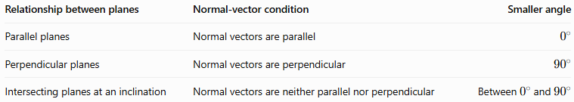
Relationship between planes | Normal-vector condition | Smaller angle
Parallel planes | Normal vectors are parallel | $$0^{∘}$$
Perpendicular planes | Normal vectors are perpendicular | $${90}^{∘}$$
Intersecting planes at an inclination | Normal vectors are neither parallel nor perpendicular | Between $0^{∘}$ and ${90}^{∘}$
Strictly speaking, two distinct parallel planes do not form a dihedral angle along a common edge because they do not intersect.

Worked Examples
# Source: AI Source: Provided by: [Data Path: Persons Table -> ID Column: 1, Name_En Column: Motasem Essam] -> From: [ChatGPT] on [7/25/2026]
Example 1: Adjacent faces of a cube
A cube has square faces that meet at right angles. Consider two adjacent faces.
The angle between their planes is
$$\boxed{θ={90}^{∘}}$$
Therefore, the dihedral angle between adjacent faces of a cube is a right angle.
Example 2: Angle between two planes using normal vectors
Suppose two planes have normal vectors
$$n_{1}=\left(1,0,0\right), n_{2}=\left(1,1,0\right).$$
First, calculate the dot product:
$$n_{1}⋅n_{2}=1.$$
Next, calculate the magnitudes:
$$\left\|n_{1}\right\|=1, \left\|n_{2}\right\|=\sqrt{2}.$$
Apply the formula:
$$\cos{ϕ}=\frac{1}{\sqrt{2}}.$$
Therefore,
$$ϕ=\cos^{-1}\left(\frac{1}{\sqrt{2}}\right).$$
Answer:
$$\boxed{ϕ={45}^{∘}}$$
The smaller angle between the two plane orientations is ${45}^{∘}$.
Example 3: Finding a supplementary dihedral angle
Suppose the smaller angle between two plane orientations is ${65}^{∘}$, and the interior dihedral angle of the solid is its supplement.
Then
$$θ={180}^{∘}-{65}^{∘}.$$
Answer:
$$\boxed{θ={115}^{∘}}$$
The interior angle is obtuse.
Example 4: Perpendicular planes
Suppose the normal vectors are
$$n_{1}=\left(1,0,0\right), n_{2}=\left(0,1,0\right).$$
Their dot product is
$$n_{1}⋅n_{2}=0.$$
Thus, the normal vectors are perpendicular, which means the planes themselves are perpendicular.
Answer:
$$\boxed{ϕ={90}^{∘}}$$

Comparison With Related Concepts
# Source: AI Source: Provided by: [Data Path: Persons Table -> ID Column: 1, Name_En Column: Motasem Essam] -> From: [ChatGPT] on [7/25/2026]
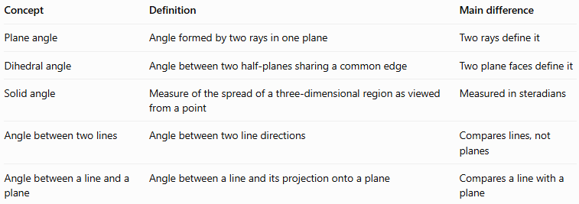
Concept | Definition | Main difference
Plane angle | Angle formed by two rays in one plane | Two rays define it
Dihedral angle | Angle between two half-planes sharing a common edge | Two plane faces define it
Solid angle | Measure of the spread of a three-dimensional region as viewed from a point | Measured in steradians
Angle between two lines | Angle between two line directions | Compares lines, not planes
Angle between a line and a plane | Angle between a line and its projection onto a plane | Compares a line with a plane

Applications
# Source: AI Source: Provided by: [Data Path: Persons Table -> ID Column: 1, Name_En Column: Motasem Essam] -> From: [ChatGPT] on [7/25/2026]
Dihedral angles are useful in:
- Architecture: measuring the angle between roof surfaces.
- Construction: checking the angle where walls or structural panels meet.
- Mechanical engineering: designing joints, folded components, and machine parts.
- Crystallography: describing angles between faces of crystals.
- Computer graphics: calculating the orientation of polygon faces in 3D models.
- Polyhedron geometry: studying the faces, edges, and interior structure of solids.

Key Points
# Source: AI Source: Provided by: [Data Path: Persons Table -> ID Column: 1, Name_En Column: Motasem Essam] -> From: [ChatGPT] on [7/25/2026]
- A dihedral angle is formed by two half-planes sharing a common edge.
- The common edge is the line where the two planes intersect.
- A cross-section perpendicular to the edge allows the angle to be measured as a plane angle.
- Adjacent faces of a cube form a \(90^\circ\) dihedral angle.
- Normal vectors can be used to calculate the smaller angle between two plane orientations.
- The interior dihedral angle of a solid can be obtuse, depending on the solid and the selected interior region.
- Distinguish the smaller angle between plane orientations from the interior dihedral angle of a particular solid.

Conclusion
# Source: AI Source: Provided by: [Data Path: Persons Table -> ID Column: 1, Name_En Column: Motasem Essam] -> From: [ChatGPT] on [7/25/2026]
The dihedral angle describes how two planes meet along a common edge in three-dimensional space. It is a fundamental concept in solid geometry because it measures the inclination of adjacent faces and helps describe the shape of polyhedra and other three-dimensional structures.
It can be understood geometrically through a perpendicular cross-section and calculated algebraically using the normal vectors of the two planes.

